DSA LAB 01: ARRAY OPERATIONS
#include<iostream>
using namespace std;
void Traversal(int arr[], int n)
{
for(int i = 0; i <= n-1; i++)
{
cout << arr[i] << endl;
}
}

void insertion(int arr[], int &n, int pos, int new_element)
{
while(pos < 0 || pos > n)
{
cout << "invalid, enter pos between 0-" << n << endl; cout << "enter pos";
cin >> pos;
}

for(int i = n; i > pos; i--)
{
arr[i] = arr[i-1];
}

arr[pos] = new_element; n++;

}

void deletion(int arr[], int &n, int pos)
{
while(pos < 0 || pos >= n)
{
cout << "invalid, enter pos between 0-" << n-1 << endl; cout << "enter pos";
cin >> pos;
}

for(int i = pos; i < n-1; i++)
{
arr[i] = arr[i+1];
}

n--;
}

int main()
{
int arr[100], n;
int choice, pos, element, new_element;

cout << "how many elements"; cin >> n;

while(n <= 0 || n > 100)
{

cout << "enter the no of elements between 1 to 100" << endl; cout << "enter no of elements";
cin >> n;
}

// Accepting the elements in array for(int i = 0; i < n; i++)
{
cout << "enter the elements" << i; cin >> arr[i];
}

while(true)
{
cout << "\n1.traversal"; cout << "\n2.insertion"; cout << "\n3.deletion"; cout << "\n4.exit";
cout << "\nenter your choice"; cin >> choice;

switch(choice)
{
case 1:
Traversal(arr, n); break;

case 2:
cout << "enter element to insert";

cin >> element;

cout << "enter pos(0 to " << n << ")"; cin >> pos;

insertion(arr, n, pos, element); break;

case 3:
cout << "enter pos(0 to " << n-1 << ")"; cin >> pos;

deletion(arr, n, pos); break;

case 4:
cout << "exit"; return 0;

default:
cout << "invalid choice";
}
}

return 0;
}

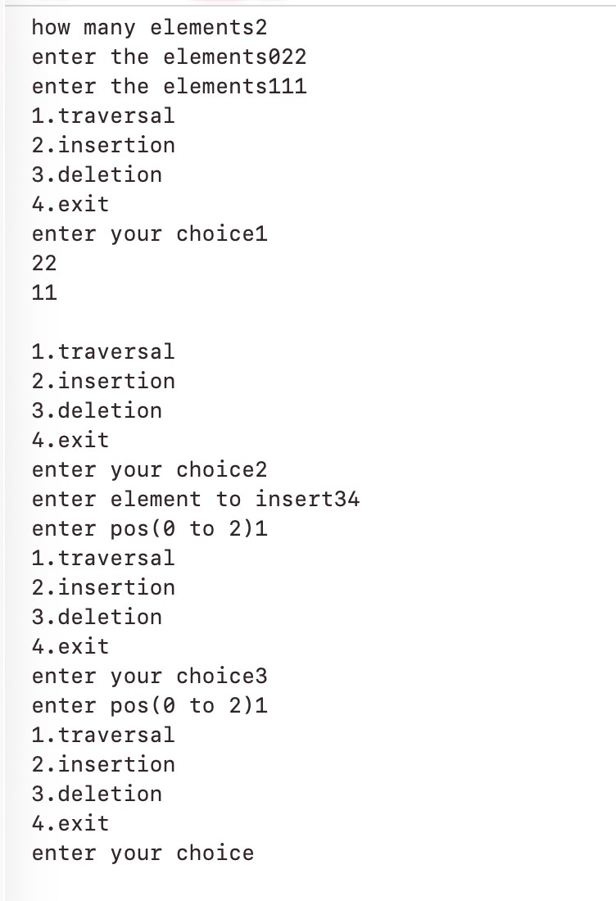
DSA LAB 02: STACK OPERATIONS
#include<iostream>

using namespace std;

// defining stack as a global variable

int myDIVB[100];

int topElement = -1;

void push(int elementValue)
{
if(topElement >= 99)
{
cout << "stack overflow" << endl;
}
else
{
topElement++;
myDIVB[topElement] = elementValue;
}
}

void pop()
{
if(topElement == -1)
{
cout << endl << "stack underflow";
}
else
{
cout << myDIVB[topElement]; topElement--;
}

}

void peek()
{
if(topElement == -1)
{
cout << endl << "stack underflow";
}
else
{
cout << myDIVB[topElement];
}
}

void display()
{
if(topElement == -1)
{
cout << endl << "stack underflow";
}
else
{
for(int i = topElement; i >= 0; i--)
{
cout << myDIVB[i] << " ";
}
}
}

// main body

int main()
{
int choice, value;

while(true)
{
cout << "\n1.push"; cout << "\n2.pop"; cout << "\n3.peek"; cout << "\n4.display"; cout << "\n5.exit";
cout << "\nenter your choice: "; cin >> choice;

switch(choice)
{
case 1:
cout << "enter element: "; cin >> value;
push(value); break;

case 2: pop(); break;

case 3:

peek(); break;

case 4: display(); break;

case 5:
cout << "exiting"; return 0;

default:
cout << "invalid choice";
}
}

return 0;
}

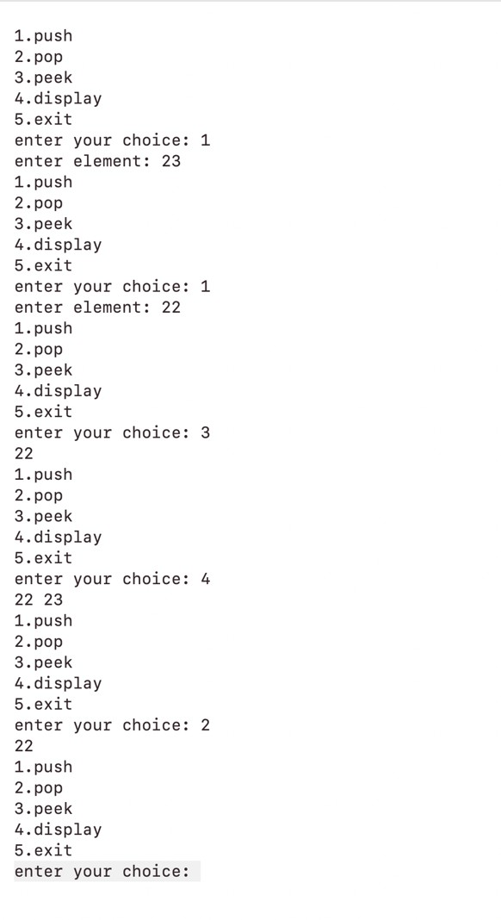

DSA LAB 03: STACK OPERATIONS USING CLASS AND PUBLIC
#include<iostream> using namespace std; class MyStack
{
public:
int top = -1;
int divBStack[100]; void push(int value){
if(top>=99){

cout<<"STACK IS FULL"<<endl; return;
}
top++; divBStack[top]=value; return;
}
void pop(){ if(top==-1){
cout<<"STACK IS EMPTY"<<endl;
return;
}
cout<<divBStack[top]<<endl; top--;
return;
}
void peek(){ if(top==-1){
cout<<"STACK IS EMPTY"<<endl;
return;
}
cout<<divBStack[top]<<endl; return;
}
void display(){ if(top==-1){
cout<<"STACK IS EMPTY"<<endl;
}

else{

for(int i=top; i>=0; i--){ cout<<divBStack[i]<<" ";
}
}
}
};
int main(){ MyStack s; int choice; int value;

do{
cout<<"\n1.push"; cout<<"\n2.pop"; cout<<"\n3.peek"; cout<<"\n4.display"; cout<<"\n5.exit"; cout<<"\nenter your choice: "; cin>>choice;

switch(choice){ case 1:
cout<<"enter value: "; cin>>value; s.push(value);
break;

case 2: s.pop();

break;

case 3:
s.peek(); break;

case 4: s.display(); break;

case 5: cout<<"exit"; return 0;

default:
cout<<"invalid choice";
}
}while(choice!=5);

return 0;
}

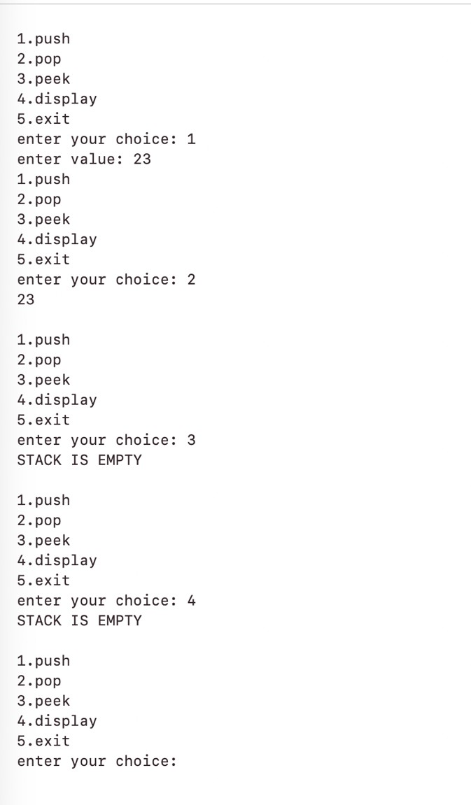

DSA LAB 03: STACK OPERATIONS USING PUBLIC AND CLASS
#include<iostream>
using namespace std;

class mystack{
public:
int mydivb[100];
int topelement = -1;

void push(int elementvalue) {
if (topelement >= 99) {
cout << "stack overflow - MAX limit reached" << endl;
} else {
topelement++;
mydivb[topelement] = elementvalue;
cout << "Element " << elementvalue << " pushed." << endl;
}
}

// pop operation void pop() {
if (topelement == -1) {
cout << "stack underflow - NO element to pop" << endl;
} else {
cout << "element popped out is: " << mydivb[topelement] << endl; topelement--;
}
}

// peek operation void peek() {
if (topelement == -1) {
cout << "the stack is empty" << endl;
} else {
cout << "the top element is: " << mydivb[topelement] << endl;
}
}

void display() {
if (topelement == -1) {
cout << "stack is empty" << endl;
} else {
cout << "Stack elements: ";
for (int i = topelement; i >= 0; i--) { cout << mydivb[i] << " ";
}
cout << endl;
}
}
};

int main() {
mystack s;
int option;
int ElementValue;

while (true) {
cout << "\nEnter the case that you want to implement" << endl; cout << "Case 1: Push the stack" << endl;
cout << "Case 2: Pop the stack" << endl; cout << "Case 3: Peek function" << endl; cout << "Case 4: Display the stack" << endl; cout << "Case 5: Exit from the loop" << endl; cout << "Enter your option: ";
cin >> option;

switch (option) {
case 1:
cout << "Enter value to push: "; cin >> ElementValue; s.push(ElementValue);
break; case 2:
s.pop();
break; case 3:
s.peek();
break; case 4:
s.display();
break; case 5:
cout << "Exiting program..." << endl;
return 0;
default:
cout << "Invalid choice, try again." << endl;
}
}
return 0;
}

